**ASSIGNMENT 1**

1:write program to test Hello World.

**public** **class** Assignment_1 {

**public** **static** **void** main(String[] args) {

System.***out***.println("Hello World");

}

}

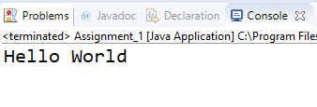

2:Write a program to adddition of two numbers .

**import** java.util.Scanner;

**public** **class** Assignment_1 {

**public** **static** **void** main(String[] args) {

**int** a,b,c;

Scanner sc;

sc=**new** Scanner(System.***in***);

System.***out***.println("Enter 1st number:");

a=sc.nextInt();

System.***out***.println("Enter 2nd number");

b=sc.nextInt();

c=a+b;

System.***out***.println("Sum of "+a+" and "+b+" is "+c);

}

}

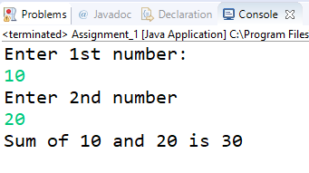

3:Write a program to swap two numbers.

**import** java.util.Scanner;

**public** **class** Assignment_1 {

**public** **static** **void** main(String[] args) {

**int** no1, no2;

Scanner sc;

sc = **new** Scanner(System.***in***);

System.***out***.println("Enter 1st number:");

no1=sc.nextInt();

System.***out***.println("Enter 2nd number:");

no2=sc.nextInt();

System.***out***.println("Before Swapping:\nNumber 1 = "+no1+" Number 2 = "+no2);

no1=no1+no2;

no2=no1-no2;

no1=no1-no2;

System.***out***.println("After Swapping:\nNumber 1 = "+no1+", Number 2 = "+no2);

}

}

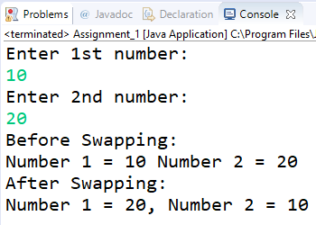

4. Write a program to accept an integer and check if it is even or odd.

**import** java.util.Scanner;

**public** **class** Assignment_Day1_4 {

**public** **static** **void** main(String[] args) {

**int** num;

Scanner sc;

sc = **new** Scanner(System.***in***);

System.***out***.println("Enter a number :");

num = sc.nextInt();

**if** (num % 2 == 0) {

System.***out***.println(num + " is an even number.");

}

**else** {

System.***out***.println(num+"is an odd number");

}

}

}

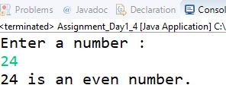

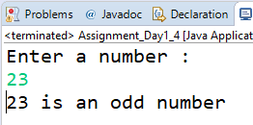

5. Write a program to accept a number and check if it is divisible by 5 and 7.

**import** java.util.Scanner;

**public** **class** Assignment_Day_1_5 {

**public** **static** **void** main(String[] args) {

**int** num;

Scanner sc;

sc = **new** Scanner(System.***in***);

System.***out***.println("Enter a number to check wheather it is divisible by 5 and 7 or not :");

num = sc.nextInt();

**if** (num % 5 == 0 && num % 7 == 0) {

System.***out***.println(num + " is divisible by 5 and 7 both.");

}

**else** {

System.***out***.println(num+" is not divisible by 5 and 7.");

}

}

}

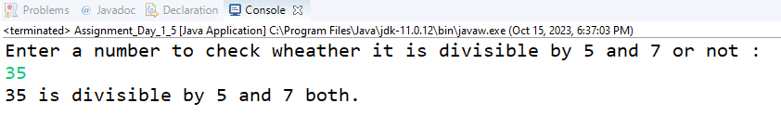

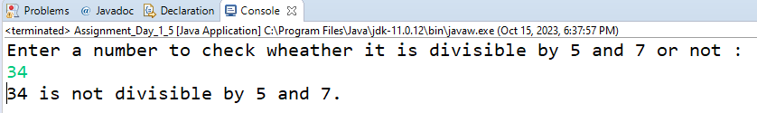

6. Write a program, which accepts annual basic salary of an employee and calculates and displays the

Income tax as per the following rules.

Basic: < 1, 50,000 Tax = 0

1, 50,000 to 3,00,000 Tax = 20%

> 3,00,000 Tax = 30%

**import** java.util.Scanner;

**public** **class** Assignment_Day_1_6 {

**public** **static** **void** main(String[] args) {

**double** basic_sal;

Scanner sc;

sc = **new** Scanner(System.***in***);

System.***out***.println("Enter the basic salary:");

basic_sal = sc.nextDouble();

**if** (basic_sal < 150000) {

System.***out***.println("Basic Salary = " + basic_sal + "\nTax = 0");

} **else** **if** (basic_sal > 150000 && basic_sal < 300000) {

System.***out***.println("Basic Salary = " + basic_sal + "\nTax = 20%" + "\nTax = " + 0.2 * basic_sal);

} **else** {

System.***out***.println("Basic Salary = " + basic_sal + "\nTax = 30%" + "\nTax = " + 0.3 * basic_sal);

}

}

}

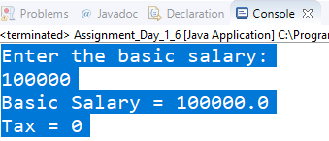

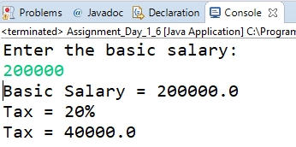

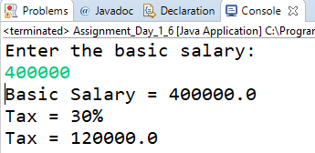

7. Accept a lowercase character from the user and check whether the character is a vowel or consonant.

(Hint: a, e, i , o, u are vowels)

**import** java.util.Scanner;

**public** **class** Assignment_Day1_7 {

**public** **static** **void** main(String[] args) {

**char** ch;

Scanner sc;

sc=**new** Scanner(System.***in***);

System.***out***.println("Enter a caharacter:");

ch=sc.next().charAt(0);

**if**(ch=='a' || ch=='e' || ch=='i' || ch=='o' || ch=='u' )

{

System.***out***.println("Entered character is a vowel.");

}

**else**

{

System.***out***.println("Entered character is consonant.");

}

}

}

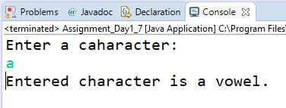

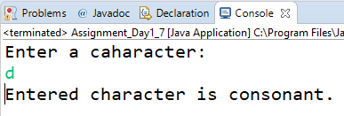

8. Write a program to input angles of a triangle and check whether triangle is valid or not.

**import** java.util.Scanner;

**public** **class** Assignment_Day_1_8 {

**public** **static** **void** main(String[] args) {

**int** a1,a2,a3;

Scanner sc;

sc = **new** Scanner(System.***in***);

System.***out***.println("Enter 1st angle:");

a1=sc.nextInt();

System.***out***.println("Enter 2nd angle:");

a2=sc.nextInt();

System.***out***.println("Enter 3rd angle:");

a3=sc.nextInt();

**if**(a1+a2+a3==180)

{

System.***out***.println("Triangle is valid.");

}

**else**

{

System.***out***.println("Triangle is invalid");

}

}

}

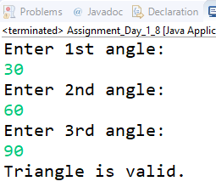

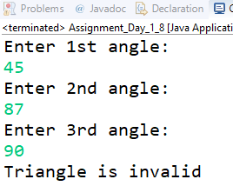

9:Write a program to find factorial of a given number. ex:no5 fact=5*4*3*2*1=120

**import** java.util.Scanner;

**public** **class** Assignment_Day_1_9 {

**public** **static** **void** main(String[] args)

{ Scanner sc;

sc=**new** Scanner(System.***in***);

System.***out***.println("Enter a number of which you want factorial:");

**int** num,fact=1;

num=sc.nextInt();

**for**(**int** i=1;i<=num;i++)

{

fact=fact*i;

}

System.***out***.println("Factorial of "+num+" is "+fact);

}

}

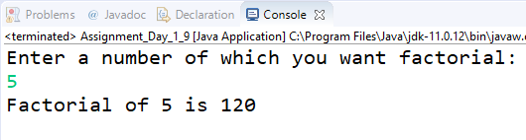

10:Write a program to find m to the power n. m=3 and n=4 so 3*3*3*3.

**import** java.util.Scanner;

**public** **class** Assignment_Day1_10 {

**public** **static** **void** main(String[] args) {

Scanner sc;

sc = **new** Scanner(System.***in***);

**int** base, power,res=1;

System.***out***.println("Enter base:");

base = sc.nextInt();

System.***out***.println("Enter power");

power = sc.nextInt();

**for**(**int** i=1;i<=power;i++)

{

res=base*res;

}

System.***out***.println(base+" to the power "+power+" is "+res);

}

}

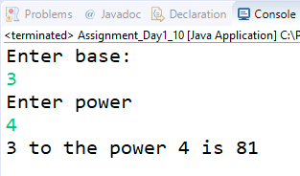

11:Check if number is a prime number or not.:

**import** java.util.Scanner;

**public** **class** Assignment_Day_1_10 {

**public** **static** **void** main(String[] args) {

Scanner sc = **new** Scanner(System.***in***);

**int** num;

**boolean** status = **false**;

System.***out***.println("Enetr a number:");

num = sc.nextInt();

**for** (**int** i = 2; i <= num / 2; i++) {

**if** (num % i == 0) {

status = **true**;

**break**;

} **else** {

}

}

**if** (status == **true**)

System.***out***.println(num + " is not prime number.");

**else**

System.***out***.println(num + " is prime");

}

}

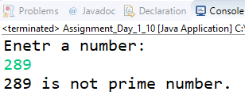

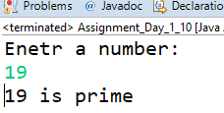

12:Sum of series :

1+2+3+….+n

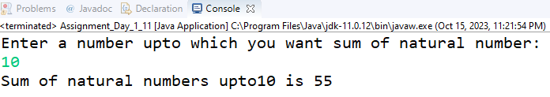

13:Check whether the number is palindrome or not?

**import** java.util.Scanner;

**public** **class** Assignment_Day_1_13 {

**public** **static** **void** main(String[] args) {

Scanner sc=**new** Scanner(System.***in***);

**int** num,temp,ch,res=0;

System.***out***.println("Enter a num:");

num=sc.nextInt();

temp=num;

**while**(num!=0)

{

ch=num%10;

res=res*10+ch;

num=num/10;

}

System.***out***.println("Given Number = "+temp+"\nSwapped Number = "+res);

**if**(temp==res)

System.***out***.println(temp+" is pallindrome number.");

**else**

System.***out***.println(temp+" is not a pallindrome number.");

}

}

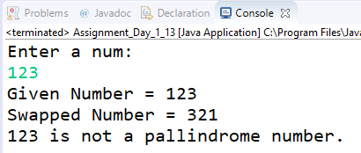

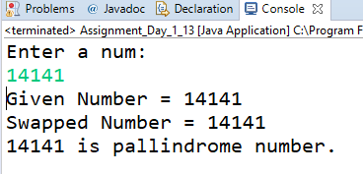

14:Write a program to find sum of all even and odd numbers between 1 to n.

**import** java.util.Scanner;

**public** **class** Assignment_Day_1_14 {

**public** **static** **void** main(String[] args) {

Scanner sc=**new** Scanner(System.***in***);

**int** num,sum_even=0,sum_odd=0;

System.***out***.println("Enter a number upto which you want sum of odd and even numbers:");

num=sc.nextInt();

**for**(**int** i=1;i<=num;i++)

{

**if**(i%2==0)

sum_even=sum_even+i;

**else**

sum_odd=sum_odd+i;

}

System.***out***.println("Sum of Odd numbers upto "+num+" is "+sum_odd);

System.***out***.println("Sum of even numbers upto "+num+" is "+sum_even);

}

}

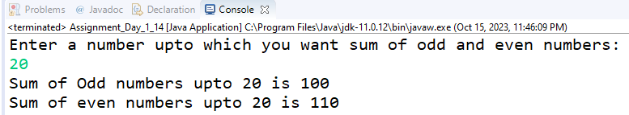

15: Write a program to enter a number and print its reverse.

**import** java.util.Scanner;

**public** **class** Assignment_Day_1_15 {

**public** **static** **void** main(String[] args) {

Scanner sc = **new** Scanner(System.***in***);

**int** temp,num,res=0,ch;

System.***out***.println("Enetr a number:");

num = sc.nextInt();

temp=num;

**while**(num!=0) {

ch=num%10;

res=res*10+ch;

num=num/10;

}

System.***out***.println("Before Swapping = "+temp);

System.***out***.println("After Swappping = "+res);

}

}

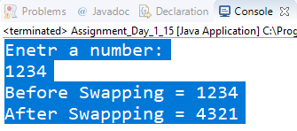

16:Write a program to print all Prime numbers between 1 to n.

**import** java.util.Scanner;

**public** **class** Assignment_Day_1_19 {

**public** **static** **void** main(String[] args) {

Scanner sc = **new** Scanner(System.***in***);

**int** num = 0, n, count;

System.***out***.println("Enter the range:");

**if** (sc.hasNextInt()) {

num = sc.nextInt();

}

**else** {

System.***out***.println("Enter an integer value.");

}

**for**(**int** j=2;j<=num;j++)

{

count=0;

**for**(**int** i=1;i<=j;i++)

{

**if**(j%i==0)

{

count++;

}

}

**if**(count==2)

{

System.***out***.print(j+" ");

}

}

}

}

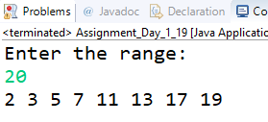

17:Write a program to check entered number is Armstrong number or not.

**import** java.util.Scanner;

**import** java.lang.Math;

**public** **class** Assignment_Day_1_17 {

**public** **static** **void** main(String[] args) {

**int** num = 0,original_number,digits=0,last,ch,sum=0;

Scanner sc = **new** Scanner(System.***in***);

System.***out***.println("Enter a number:");

**if**(sc.hasNextInt())

{

num =sc.nextInt();

}

**else**

{

System.***out***.println("Enter an integer value");

System.*exit*(0);

}

original_number=num;

//count number of digits

**while**(num!=0)

{

num=num/10;

digits++;

}

//System.out.println(digits);

num=original_number;

**while**(num!=0)

{

ch=num%10;

sum=sum+(**int**)(Math.*pow*(ch,digits));

num=num/10;

}

**if**(sum==original_number)

System.***out***.println(sum+" is Armstrong Number.");

**else**

System.***out***.println("Res = "+sum+"\n"+sum+" is not an Armstrong Number");

}

}

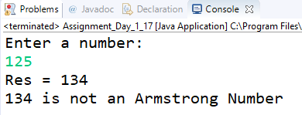

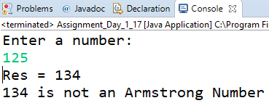

18:Write a program to find greatest of three numbers using nested if-else.

**import** java.util.Scanner;

**public** **class** Assignment_Day_1_18 {

**public** **static** **void** main(String[] args) {

Scanner sc=**new** Scanner(System.***in***);

**int** n1,n2,n3;

System.***out***.println("Enter 1st number:");

n1=sc.nextInt();

System.***out***.println("Enter 2nd number:");

n2=sc.nextInt();

System.***out***.println("Enter 3rd number:");

n3=sc.nextInt();

**if**(n1>n2 && n1>n3)

System.***out***.println(n1+" is the greatest.");

**else** **if**(n2>n1 && n2>n3)

System.***out***.println(n2+" is the greatest.");

**else**

System.***out***.println(n3+" is the greatest.");

}

}

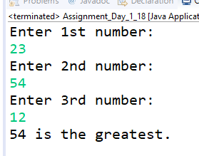

19:Create menu driven program for Pizza Shop.And display total amount,

**import** java.util.Scanner;

**public** **class** Assignment_Day_1_22 {

**public** **static** **void** main(String[] args) {

**int** ch1, ch = 0, total = 0, qty;

Scanner sc = **new** Scanner(System.***in***);

System.***out***.println("1.Onion = 70.00/- \n2.Paneer = 100/- \n3.Tomato = 90/- \n4.Cheese = 70/- \n5.Exit");

**do** {

System.***out***.println("Enter you choice:");

ch1 = sc.nextInt();

**switch** (ch1) {

**case** 1: {

System.***out***.println("Onion Pizza\nEnter Quantity:");

qty = sc.nextInt();

total = total + qty * 70;

**break**;

}

**case** 2: {

System.***out***.println("Paneer Pizza\nEnter Quantity:");

qty = sc.nextInt();

total = total + qty * 100;

**break**;

}

**case** 3: {

System.***out***.println("Tomato Pizza\nEnter Quantity:");

qty = sc.nextInt();

total = total + qty * 90;

**break**;

}

**case** 4: {

System.***out***.println("Cheese Pizza\nEnter Quantity:");

qty = sc.nextInt();

total = total + qty * 70;

**break**;

}

**case** 5:

**break**;

**default**:

System.***out***.println("Enter Invalid Option");

**break**;

}

} **while** (ch1 != 5);

System.***out***.println("Total Amount Rs." + total + "/-");

}

}

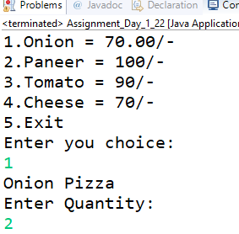

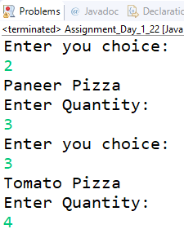

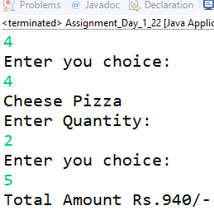

20:Accept a single digit from the user and display it in words. For example, if digit entered is 9, display Nine.

**import** java.util.Scanner;

**public** **class** Assignment_Day_1_20 {

**public** **static** **void** main(String[] args) {

Scanner sc=**new** Scanner(System.***in***);

**int** num;

System.***out***.println("Enter a number:");

num=sc.nextInt();

**switch**(num)

{

**case** 1:

System.***out***.println("One");

**break**;

**case** 2:

System.***out***.println("Two");

**break**;

**case** 3:

System.***out***.println("Three");

**break**;

**case** 4:

System.***out***.println("Four");

**break**;

**case** 5:

System.***out***.println("Five");

**break**;

**case** 6:

System.***out***.println("Six");

**break**;

**case** 7:

System.***out***.println("Seven");

**break**;

**case** 8:

System.***out***.println("Eight");

**break**;

**case** 9:

System.***out***.println("Nine");

**break**;

**default**:

System.***out***.println("Enter a single digit number");

}

}

}

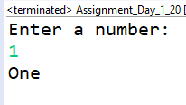

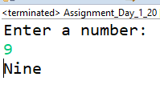

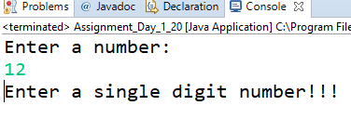

21. Write a program, which accepts two integers and an operator as a character (+ - * / ), performs the

corresponding operation and displays the result.

**import** java.util.Scanner;

**public** **class** Assignment_Day_1_21 {

**public** **static** **void** main(String [] args)

{ **int** ch,n1,n2;

Scanner sc=**new** Scanner(System.***in***);

**do**

{

System.***out***.println("1. Add 2.Subtract 3.Multiply 4.Divide 5.Exit");

System.***out***.println("Enter a choice:");

ch=sc.nextInt();

**switch**(ch)

{

**case** 1:

System.***out***.println("Enter 1st number:");

n1=sc.nextInt();

System.***out***.println("Enter 2nd number:");

n2=sc.nextInt();

System.***out***.println(n1+" + "+n2+" = "+(n1+n2));

**break**;

**case** 2:

System.***out***.println("Enter 1st number:");

n1=sc.nextInt();

System.***out***.println("Enter 2nd number:");

n2=sc.nextInt();

System.***out***.println(n1+" - "+n2+" = "+(n1-n2));

**break**;

**case** 3:

System.***out***.println("Enter 1st number:");

n1=sc.nextInt();

System.***out***.println("Enter 2nd number:");

n2=sc.nextInt();

System.***out***.println(n1+" * "+n2+" = "+n1*n2);

**break**;

**case** 4:

System.***out***.println("Enter 1st number:");

n1=sc.nextInt();

System.***out***.println("Enter 2nd number:");

n2=sc.nextInt();

**if**(n2!=0)

{

System.***out***.println(n1+" / "+n2+" = "+n1/n2);

**break**;

}

**else**

System.***out***.println("Enter a non-zero denominator.");

**case** 5:

System.***out***.println("-------Program terminated---------");

**break** ;

**default**:

System.***out***.println("Enter a valid choice");

}

}**while**(ch!=5);

}

}

